Creating an Editorial Cartoon
Social Studies 7

An editorial cartoon is a powerful way to express an opinion about current events. Editorial cartoonists often comment on politics and social issues.

Some of the techniques they use to get their message across are:

- Symbols- are simple pictures that stand for something.

- Humour- poke fun at powerful people/ issues

- Caricatures- often exaggerate one or more physical features of a public figure, which helps to identify who is in the cartoon.

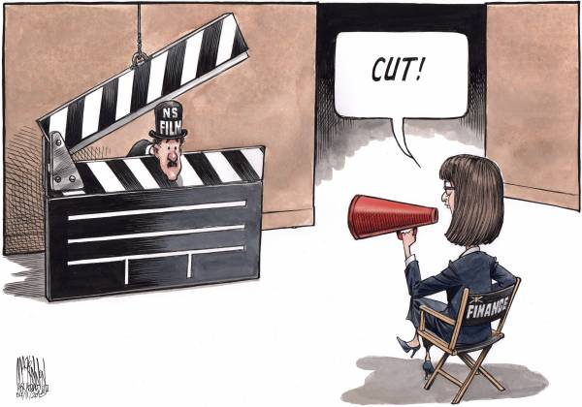

Assignment:
Imagine that you are a citizen of one of the BNA colonies (choose ONE) and take a stand either for or against Confederation. Show your opinion in an editorial cartoon.

