Confederation Achieved
Social Studies 7

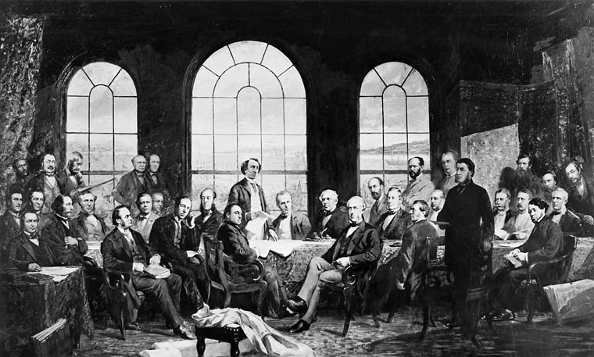

Read pages 131- 133 and answer the following questions.

1. What date did the Queen of England sign the document that created the Dominion of Canada?
______________________________________________________________________________________

2. Which provinces helped to make up the Dominion of Canada?
______________________________________________________________________________________

3. Who was the first prime minister of Canada? Provide 3 facts about him. (You may need to use your iPad.)

______________________________________________________________________________________
______________________________________________________________________________________
______________________________________________________________________________________

4. What were the main issues that caused New Brunswick to change their minds about Confederation?

______________________________________________________________________________________
______________________________________________________________________________________
______________________________________________________________________________________

5. Summarize the 4 key points of the British North America Act, 1867.
______________________________________________________________________________________
______________________________________________________________________________________
______________________________________________________________________________________

6. What did the BNA Act say about Aboriginal Peoples? Do you think this was fair? Please explain.

______________________________________________________________________________________
______________________________________________________________________________________
______________________________________________________________________________________

