Name: \_\_\_\_\_\_\_\_\_\_\_\_\_\_\_\_\_\_\_\_\_\_\_\_\_\_

**Canadian Provinces Review**

**Social Studies 7**

Click on the map of Canada to hear Raffi’s song “C-A-N-A-D-A” and discuss how you think that Canada is reflected in this song with your group. Do you think that this song is a fair representation of Canada?

[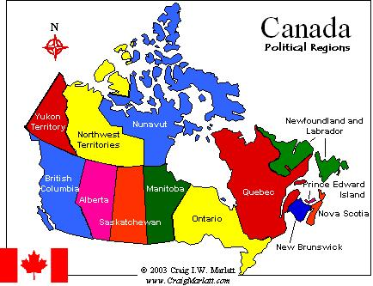](https://www.youtube.com/watch?v=aHO8xAe-FKs)

Click on the flag of each of the provinces/ territories listed below. The link will take you to information about the capital city for each province/ territory in either a Word Document or via a website. Fill in the correct capital city name in the chart… Don’t be afraid to take a guess before you click on the flag!

|  |  |
| --- | --- |
| **Province/ Territory** | **Capital City** |
| Newfoundland and Labrador [Thaw Space:ssrsb:Desktop:flag-canada-newfoundland-labrador.gif](http://www.stjohns.ca) |  |
| Nova Scotia [Thaw Space:ssrsb:Desktop:ns.jpg](#Halifax) |  |
| Prince Edward Island [Thaw Space:ssrsb:Desktop:flag-canada-pei.gif](http://www.city.charlottetown.pe.ca) |  |
| New Brunswick [Thaw Space:ssrsb:Desktop:1920px-Flag_of_New_Brunswick.svg.png](#Fredericton) |  |
| Quebec |  |
| Ontario [Thaw Space:ssrsb:Desktop:caonlag.gif](#Toronto) |  |
| Manitoba [Thaw Space:ssrsb:Desktop:canadia_flag_mb.jpg](#Winnipeg) |  |
| Saskatchewan [Thaw Space:ssrsb:Desktop:saskatchewan-flag.png](#Regina) |  |
| Alberta [Thaw Space:ssrsb:Desktop:index.jpg](http://www.edmonton.ca) |  |
| British Columbia [Thaw Space:ssrsb:Desktop:flag-canada-britishcolumbia.gif](#Victoria) |  |
| Nunavut [Thaw Space:ssrsb:Desktop:index.jpg](#Iqaluit) |  |
| Northwest Territories [Thaw Space:ssrsb:Desktop:nt-lgflag.gif](#Yellowknife) |  |
| Yukon Territory [Thaw Space:ssrsb:Desktop:2800px-Flag_of_Yukon.svg.png](http://www.city.whitehorse.yk.ca) |  |

**Canadian Capital Cities [](#Title)**

**Halifax**

Halifax was founded as a port city and is one of the largest cities in Atlantic Canada.

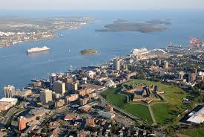

**Yellowknife**

This capital city was built on the gold rush and now thrives on diamond mining.

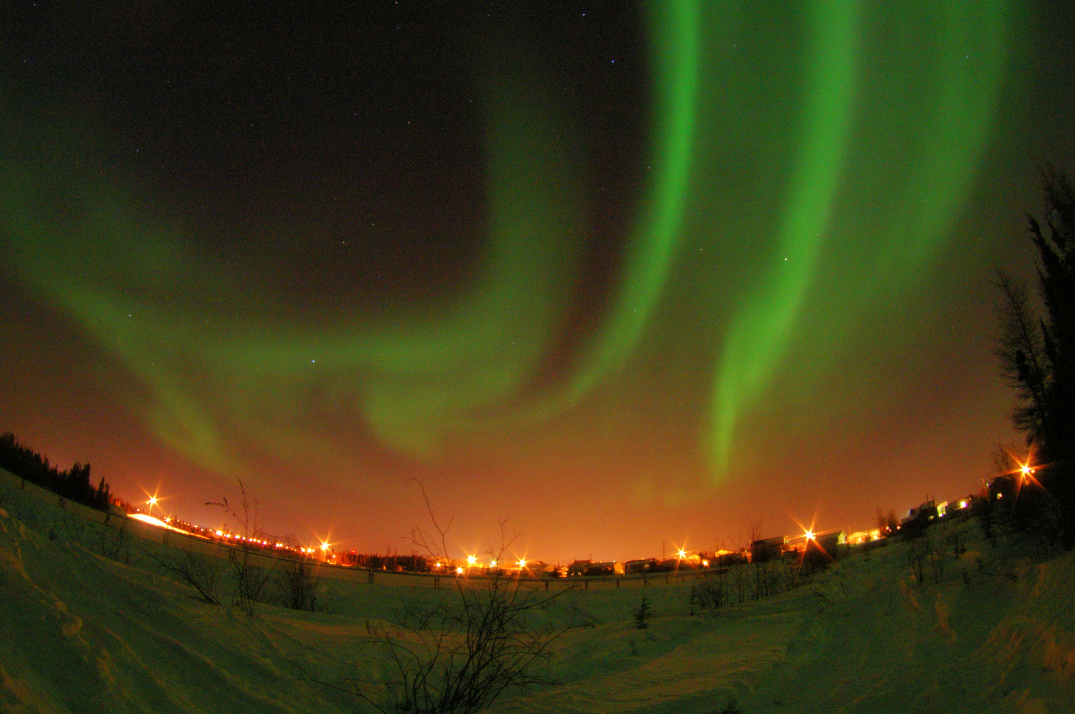

**Toronto**

This capital city has the largest population in Canada and is one of the most diverse with over 180 different languages spoken.

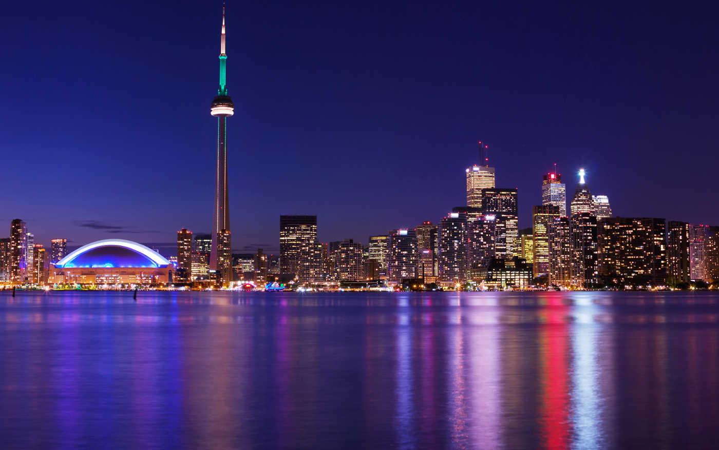

**Fredericton**

This capital city is an important part of its province’s cultural and educational centre and is the third largest city on the province.

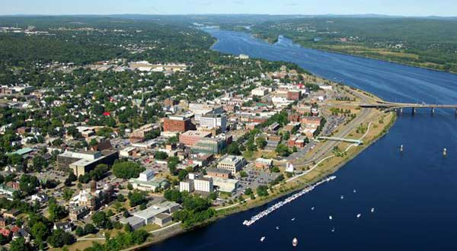

**Iqaluit**

Iqaluit can easily be described as one of Canada’s “coolest” cities!

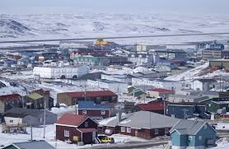

**Regina**

This city is the main local for training the Royal Canadian Mounted Police.

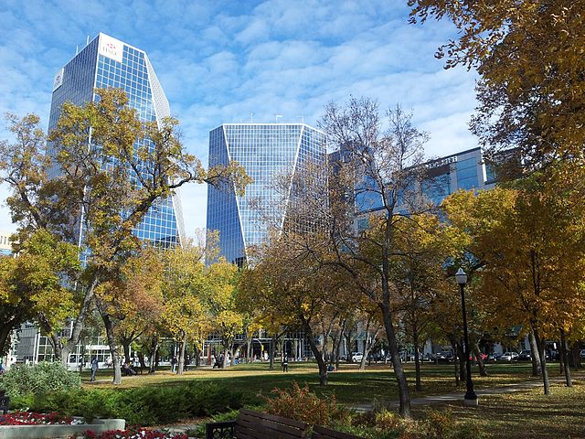

**Victoria**

Victoria was originally a trading post for the Hudson’s Bay Trading Company before becoming the second largest city in its province.

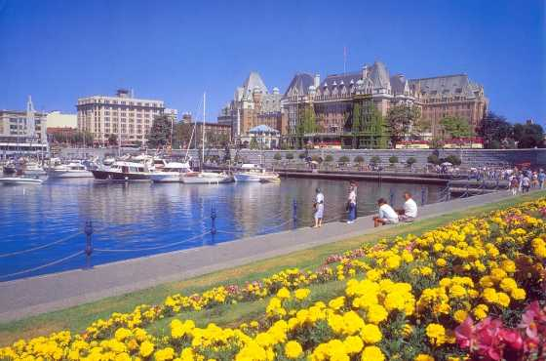

**Winnipeg**

Winnipeg is a city very close to the longitudinal centre of North America.

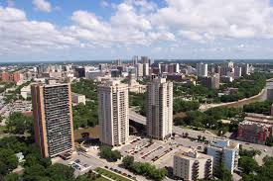

**Quebec City**

This city is one of the oldest European settlers in North America.

